# Lecture Notes

## Supervised Learning

### Lesson 1: Decision Trees

### Lesson 2: Regression & Classification

### Lesson 3: Neural Networks

### Lesson 4: Instance Based Learning

### Lesson 5: Ensemble – Bagging & Boosting

### Lesson 6: Kernel Methods - SVMs

### Lesson 7: Computational Learning Theory

### Lesson 8: VC Dimensions

### Lesson 9: Bayesian Learning

### Lesson 10: Bayesian Inference

## Unsupervised Learning

### Lesson 1: Random Optimization

### Lesson 2: Clustering

Unsupervised learning

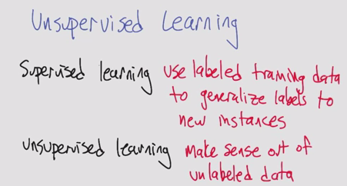

* One of the classic unsupervised learning problems is the Clustering Problem
  + It doesn’t have to be an actual distance, just has to be a similarity (like in kNN)

Basic clustering problem

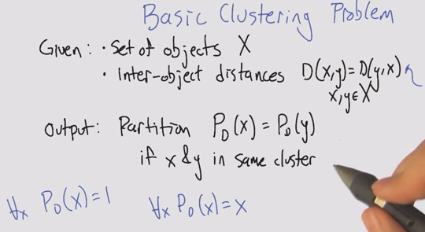

* + Trivial clusters: we can all be humans (one big cluster); we can all be ourselves (one cluster per instance)

Algorithm 1: Single Linkage Clustering (SLC)

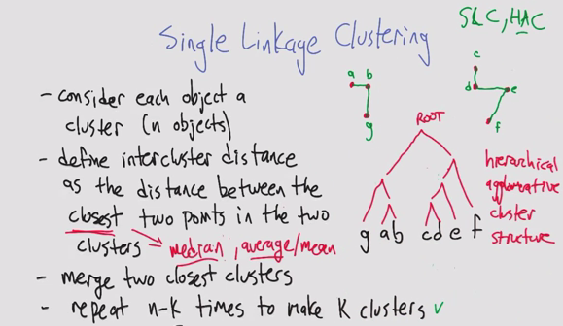

Running Time of SLC

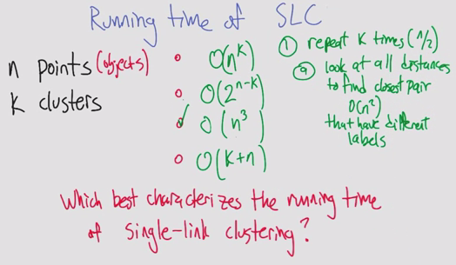

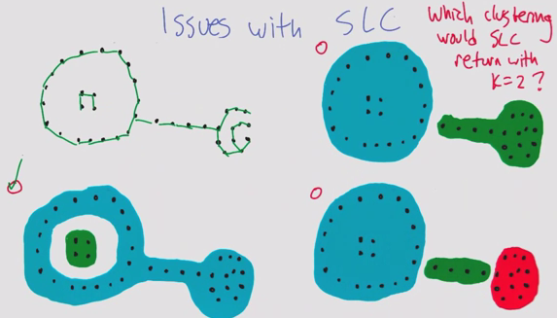

Algorithm 2: k-means Clustering

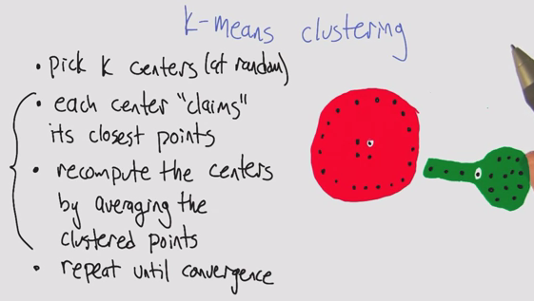

k-means Euclidean space (Part 1,2). Error does not increase, and breaks ties

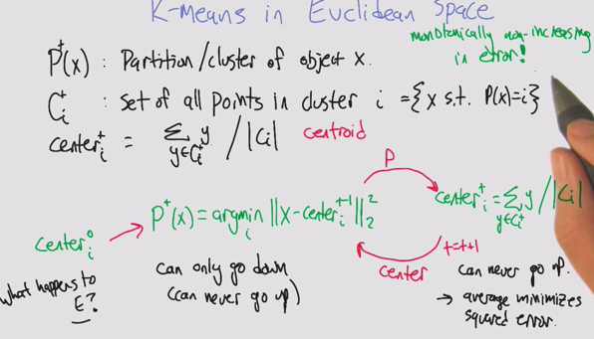

* K-means as optimization. Errors as scores. Like hill climbing.
* Monotonically non-increasing in error converges because there are a finite number of objects, even though it’s an infinite space
* You may have a point that goes between two partitions equally, so you need a way of breaking ties
  + Tendency to go to smaller cluster

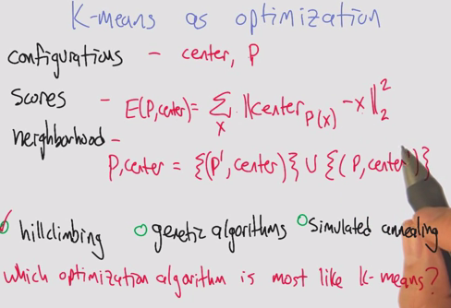

Properties of k-means clustering

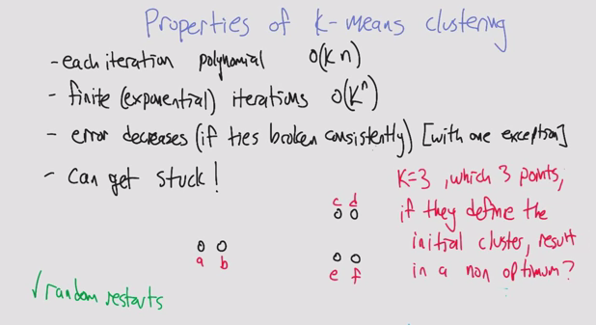

* How do you avoid non-optimum clustering?
  + Random restarts
  + Choosing centers that are furthest apart

Soft clustering

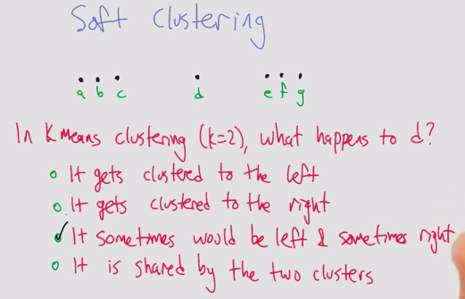

* Example of how the initial centers affects the end convergence
  + D would end up on the right if you start with a/b center, left if you start with f/g and would depend on tie breaking if a/g

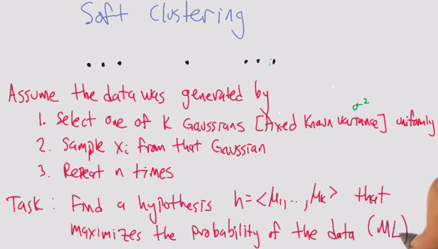

* Thinking bayesianly, given the data we’re going to make some assertions

Maximum likelihood Gaussian

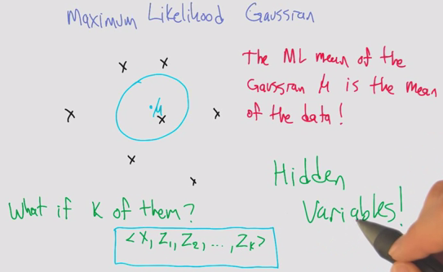

* Using hidden variables to break up the problem in a convenient way
* X lies in one of the clusters Zn

Algorithm 3: Expectation maximization

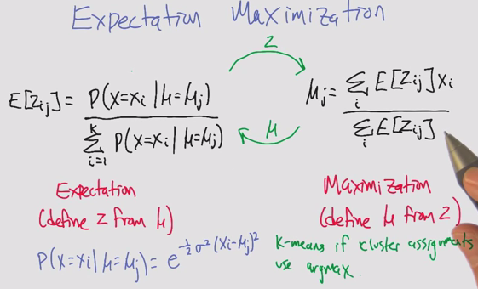

* Similar to k-means at an algorithmic level
* Tick tock between expectation (E)and maximization (miu)
* Maximization allows for partials / weighted average.

EM Example

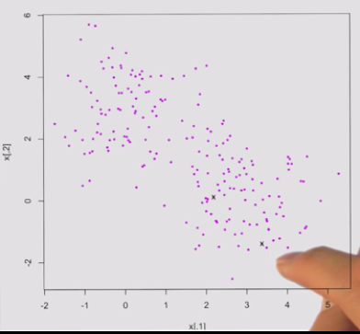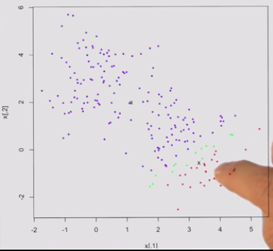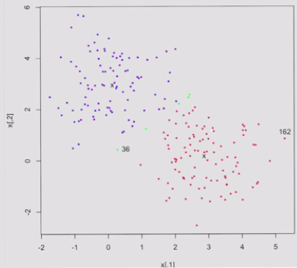

* Pick 2 centers, select 2 points randomly
* Run iteration of EM
  + Expectation
  + Move centers
  + Label the band in the middle that aren’t deeply one or the other
* Not forced to make a decision

Properties of EM

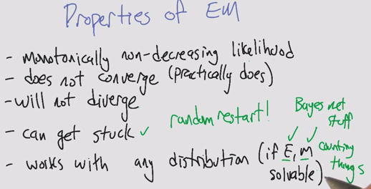

* Sometimes E or M can be hard

Clustering Properties

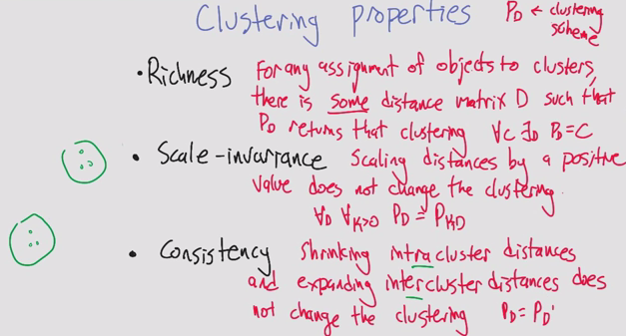

* Consistency is harder to visualize
  + If you make the objects in a cluster more similar, and the other ones more dissimilar, the clusters do not change

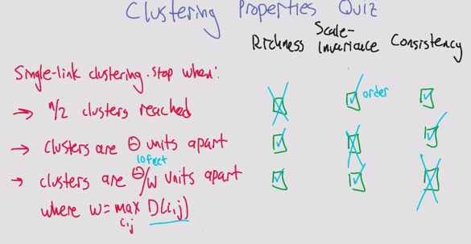

Impossibility Theorem

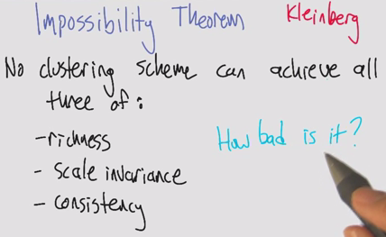

* Defined by Kleinberg
* All 3 are mutually contradictory

Summary

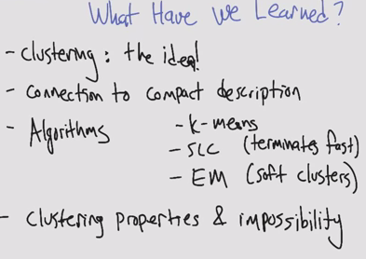

### Lesson 3: Feature Selection

Introduction

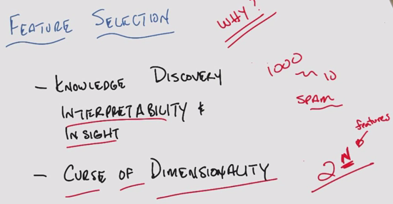

* Feature selection tends to be ignored in the realm of ML

Algorithms

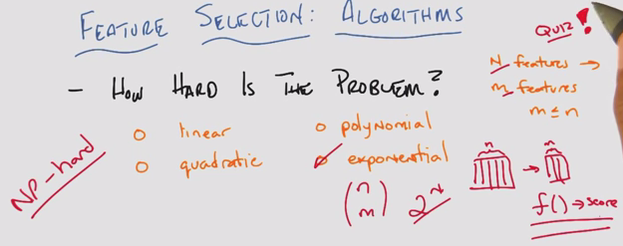

Algorithms: Filtering and wrapping

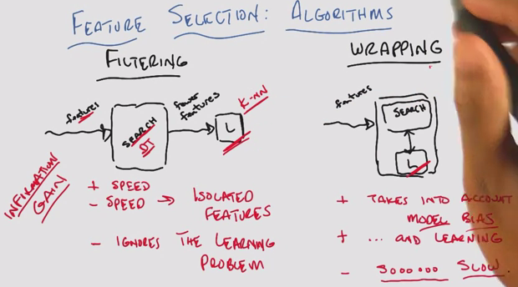

* Tradeoffs: speed, feedback
* Imagine filtering is like decision trees
* Wrapping requires cross validation, tons of computations

Methods for Filtering/Wrapping

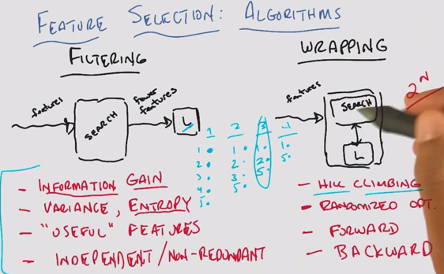

* Forward/backward search. Forward is like hill climbing if you do it one at a time
* Forward is like building the team one player at a time, backward is like removing one a time

Zero training error

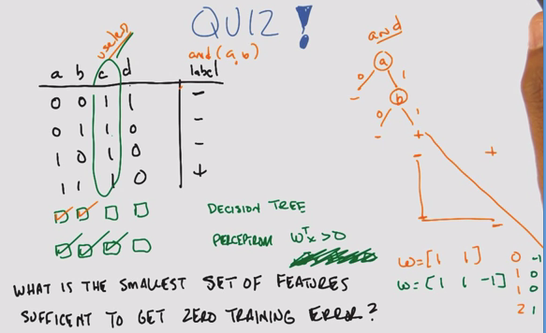

* You can use information gain, entropy, variance to determine what’s relevant
* DT: Build a decision tree
* Perceptron: Write 2D plane. Without intercept, it’s a origin limited perceptron
  + Use a 3rd feature as the intercept

Relevance

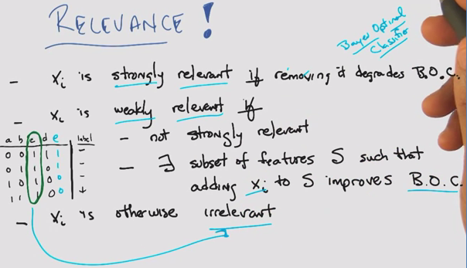

* B is strongly relevant, A/E is weakly relevant. C is irrelevant
* BOC: Bayes optimal classifier, as discussed earlier in class

Usefulness

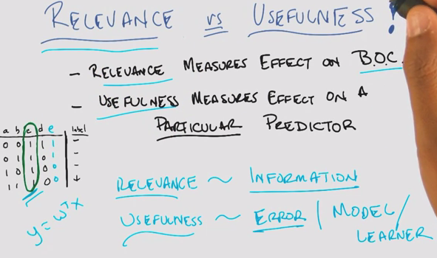

* Look at the cluster changes based on relevance and usefulness

Summary

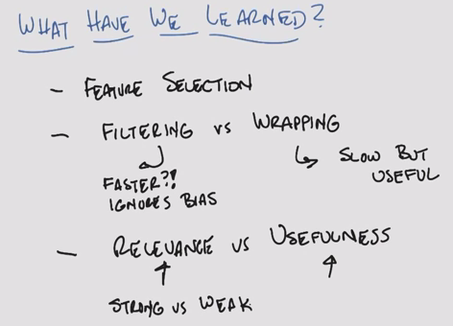

### Lesson 4: Feature Transformation

Intro

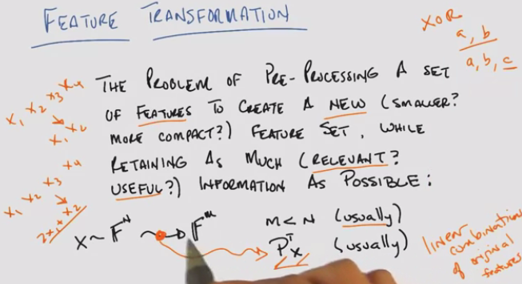

* How is this different from feature selection?
  + Think of this as a subset of feature selection
  + Transformation into a smaller subset, such that you have linear combinations of original features
  + Don’t necessarily need to go into fewer dimensions
    - We’ve done this before in Perceptrons, Kernels, XOR

Why Feature transformation?

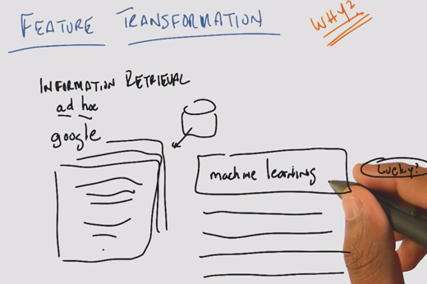

* Example: ad hoc because you don’t know what the retrieval is going to be, like Google

What are our features?

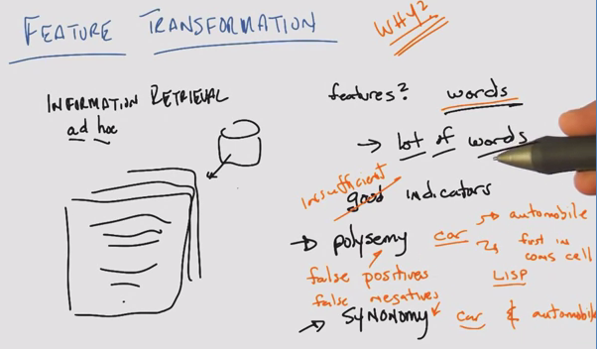

* A lot of words >>> curse of dimensionality
* Polysemy: word has multiple meanings. False positives
* Synonymy: same meaning expressed in different words. False negatives

Principal Components Analysis

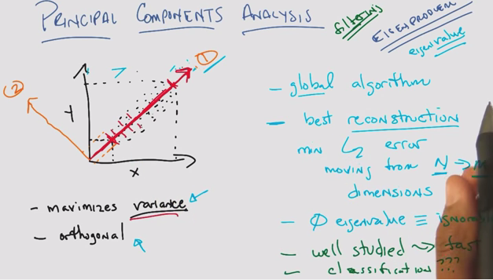

* Projecting 2D data onto x or y axis is an example of feature selection
* Projecting onto a diagonal plane maximizes variance on 1 feature
* PCA
  + 1. Maximizes variance
  + 2. Orthogonal
* Like filtering
* Reconstruction: You can reconstruct all the original data with the new axes
* Tend to subtract the mean from the data to normalize to the origin, to look for correlation
* Eigenvalue properties

Independent Components Analysis

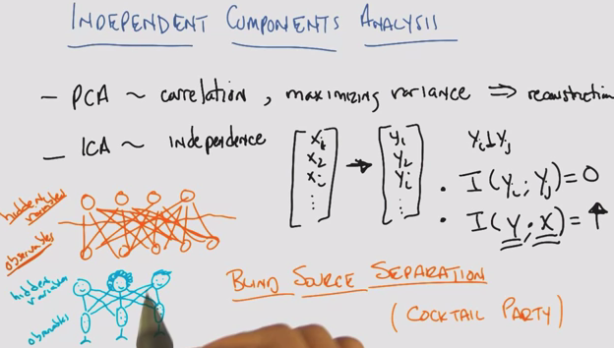

* PCA ~ correlation, maximizing variance => reconstruction
* ICA ~ mutual independence
* Blind source separations (cocktail party)
  + Trying to listen to one person at a party, while cutting out the noise of other conversations
  + Online Demo: <http://research.ics.aalto.fi/ica/cocktail/cocktail_en.cgi>

Matrix

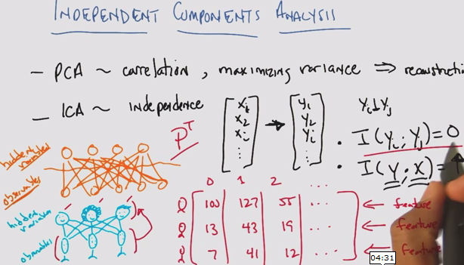

PCA vs ICA

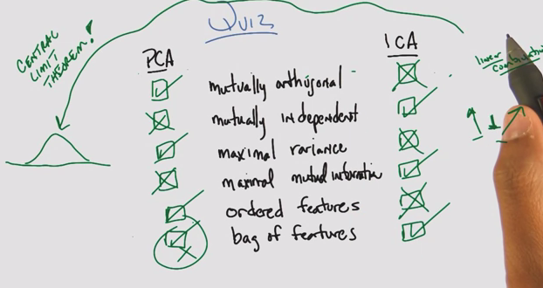

* PCA is trying to find things that are uncorrelated, which is not the same as statistically independent
  + However, when all of the data is Gaussian, it is possible for PCA to both represent data that is mutual orthogonal  ***and*** mutually independent
* ICA assuming highly non-normal
* ICA: Mutually independent projections, mutual information between old and new
* PCA/ICA fundamental assumptions are different, both trying to represent the data

PCA vs. ICA cont’d

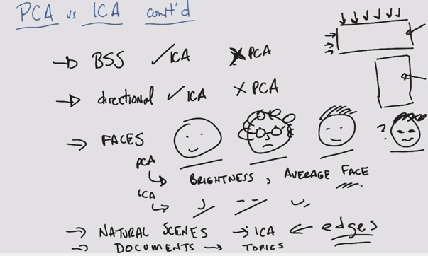

* ICA tends to pull out edges from images, therefore we can use faster algorithms that find edges as a substitute

Alternatives

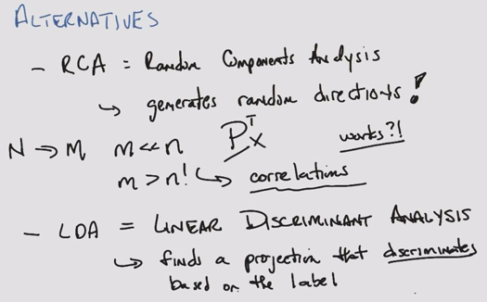

* RCA: Random components analysis
* M tends to be bigger than m in PCA

Summary

* ICA: probability. Hard to find, more expensive, but when it does it produces a satisfying answer
* PCA: linear algebra. Well understood, not exactly what you want

### Lesson 5: Information Theory

Intro

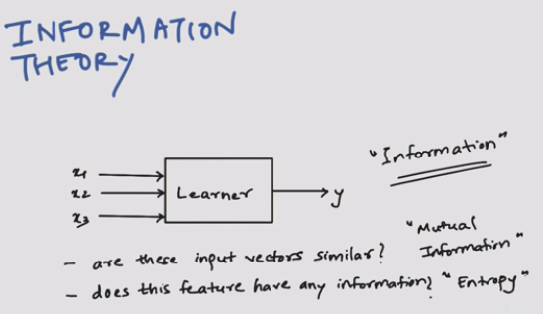

* Mutual information vs. entropy

History

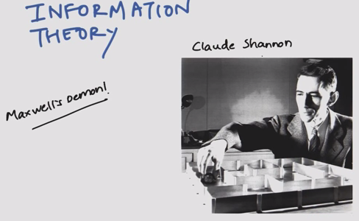

* Claude Shannon and messages
* Maxwell’s demon

Message example

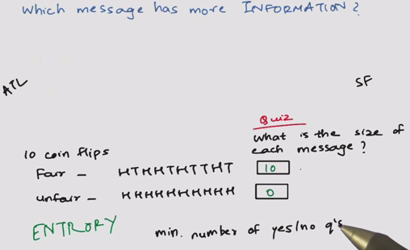

New message example

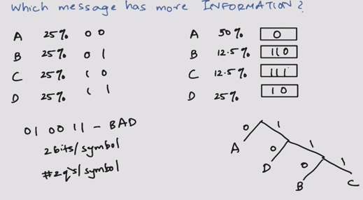

* 25% equal:
  + 2 bits per symbol
  + 2 qs per symbol
* Non-equal

Expected size of message

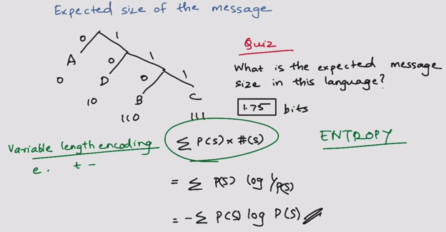

* Variable length encoding, 1.75 bits
* Entropy = #Bits = probability (symbol) * # symbols

Information between two variables

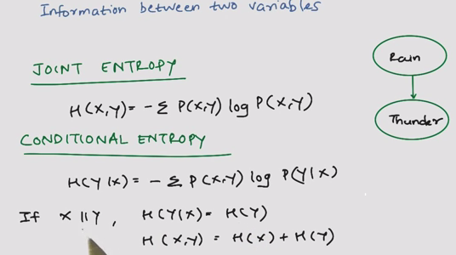

* Joint entropy
* Conditional entropy

Mutual information

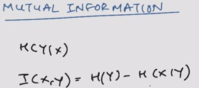

Two independent coins

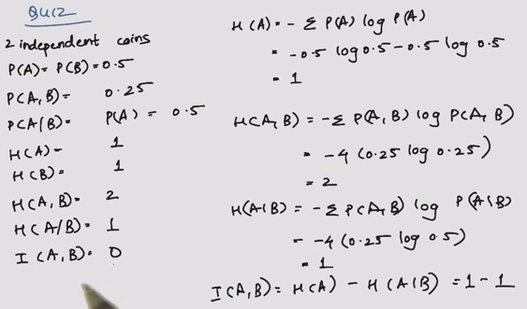

* Why n=4 for entropy?

## Two dependent coins

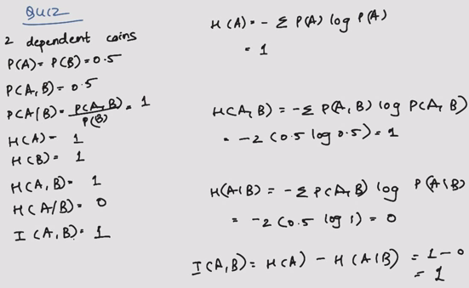  
Kullback-Leibler Divergence

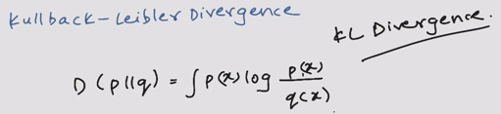

* Distance metric that does not follow triangle law
* Substitute to Least Squares

Summary

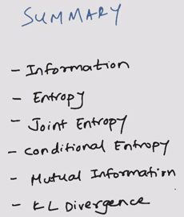

## Reinforcement Learning

### Lesson 1: Markov Decision Processes

Decision Making and Reinforcement Learning

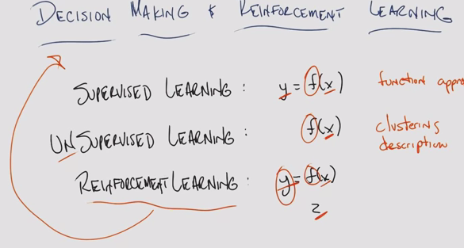

The World

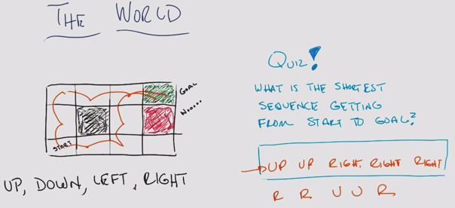

The World II

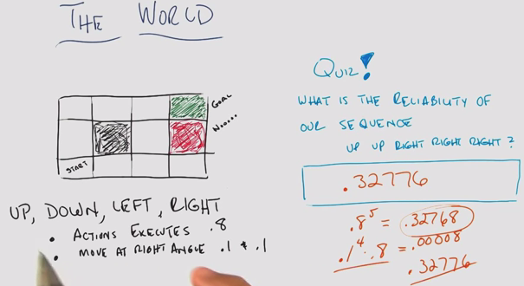

* Plan for when something “goes wrong”

Markov Decision Processes

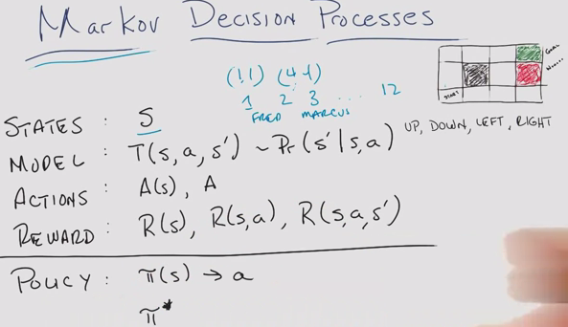

* S: State – grid location
* T: Transition
* Pr: Probability
* A: Action: Up down left right
* R: Reward

Markovian Property

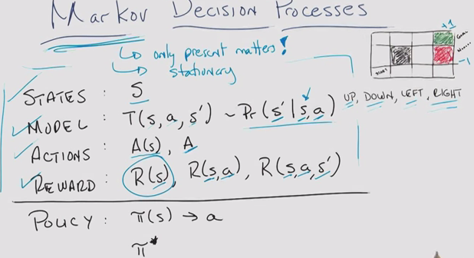

* Markovian: Only the present matters (not the past)
  + You can turn almost anything into a Markovian
* The roles, world, model are stationary
* Rewards represent domain knowledge

Rewards

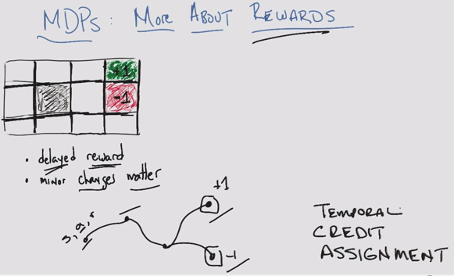

* Delayed reward, unknown at the time the action was made
* (temporal) Credit assignment problem

Example

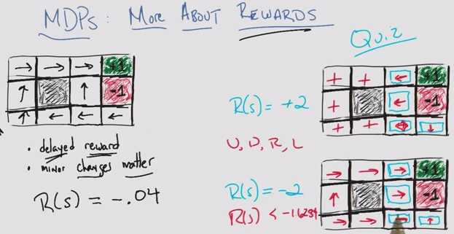

* Reward of -0.04 for all unlabelled states, encourage reaching the goal
* Like walking on hot sand trying to get to the shore
* Minor changes in your rewards matter
* Since this is Markovian, some states don’t matter
* Can be solved using expected value

Sequences of Rewards: Assumptions

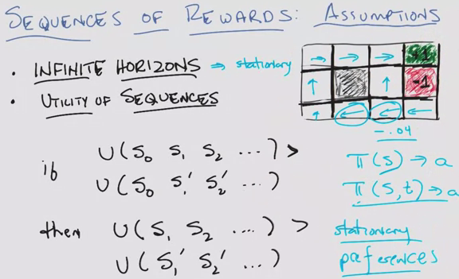

* Stationary
* Policy: account for state AND time (not for this course)
* Utility sequences (prior states don’t matter)

Example

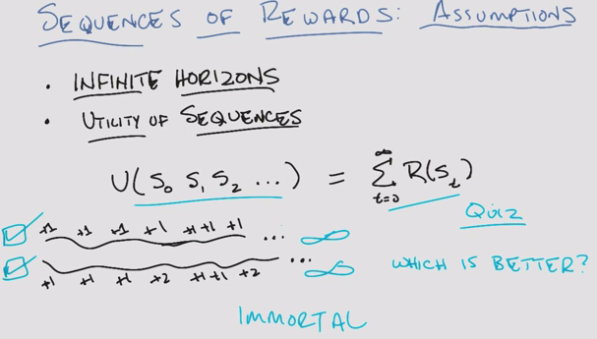

* Given this reward scheme, both approach infinity, so neither is better!

Example with different rewards:

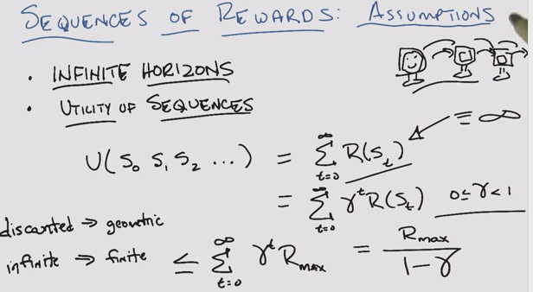

* Discounted rewards brings infinite > finite

Sequences of Rewards – Assumptions

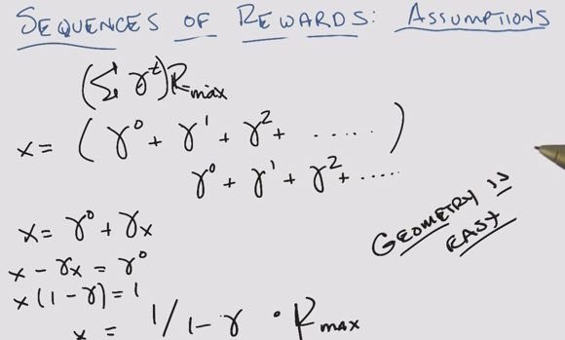

Policy

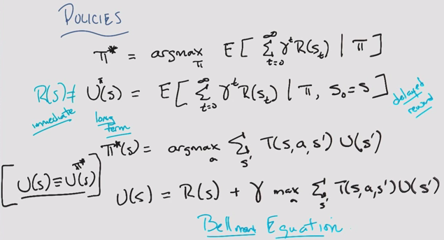

* Reward != utility
* Assume ”true” utility of the state
* Bellman Equation: the key recursive equation in MDP

Finding policies

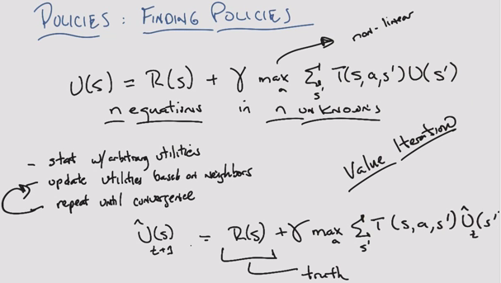

* Adding to arbitrary utility, more and more truth, and estimate is discounted. Will converge
* Value (utility) iteration

Policy quiz

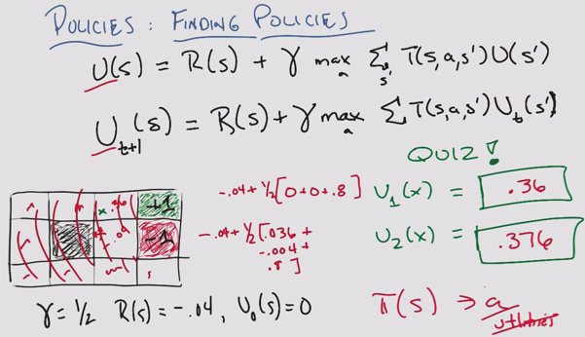

* Policy is like classification, utility like regression

Finding Policies 3

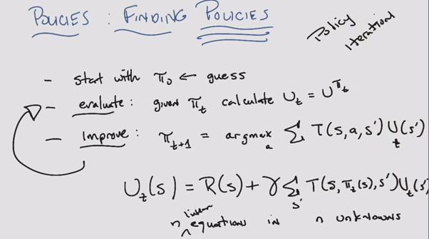

* Max was non-linear, but now this is linear
* Policy iteration (as opposed to utility iteration seen before)
* Guaranteed to converge

Summary

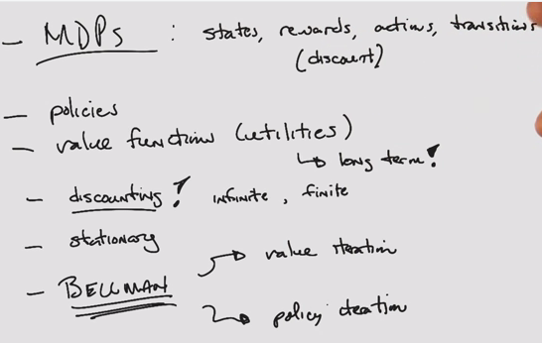

### Lesson 2: Reinforcement Learning

Application Program Interface (API)

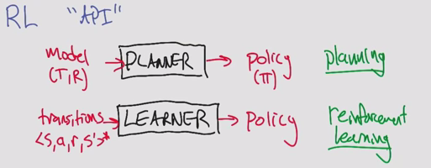

* Compute a policy vs. learn a policy

Rat Dinosaur

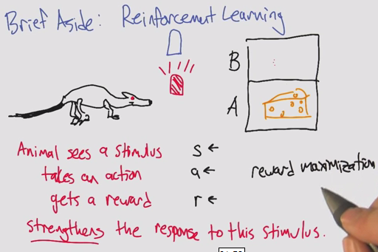

* Reinforcement learning comes from psychology
* Computer science does not focus on strengthening. Focus on reward maximization

Other APIs

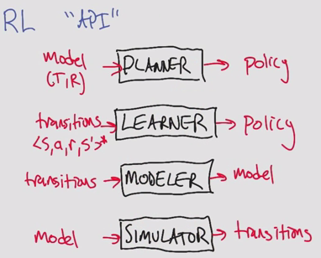

* Can be linked together to create different types of policies

Types of Reinforcement learning

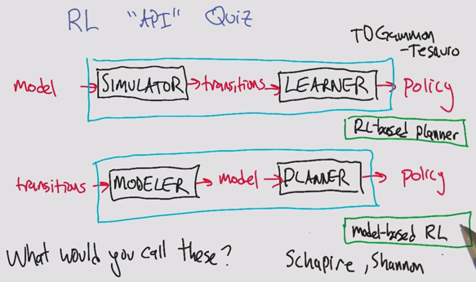

* Schapire: Boosting
* Shannon: Information Theory

3 approaches to reinforcement learning

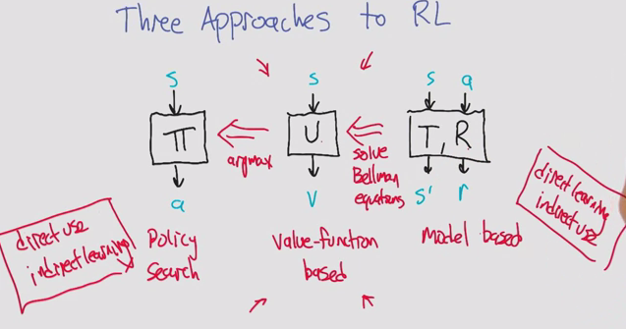

1. Policy search: Temporal credit assignment problem. Indirect learning. You learn from delayed reward.
2. Valued function based: You learn from the utility, or expected value of reward. Main focus
3. Model-based: Direct learning. Expensive Computation.

New kind of value function

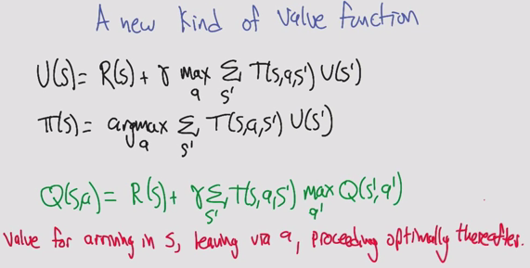

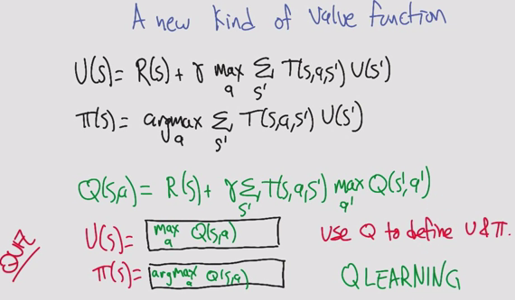

* Q: quality (other letters taken)
* Insert a utility step to compare the actions

Q-learning quiz

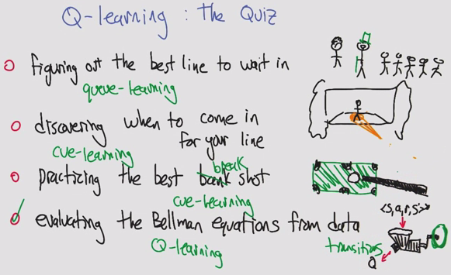

Estimating Q

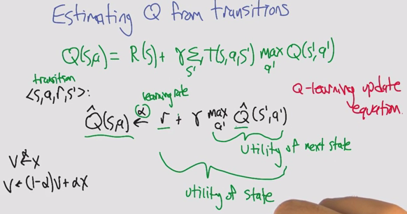

* Can’t compute Q because we don’t know R or T
* In MDPs, we do have R and T

Learning incrementally

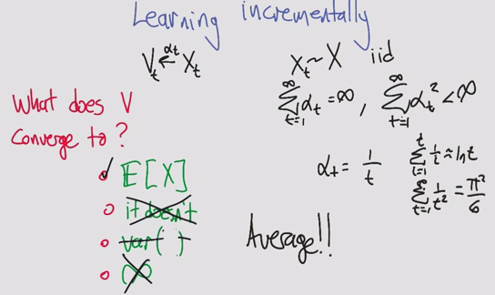

* Basal problem (pi^2/6)

Estimating Q from transitions

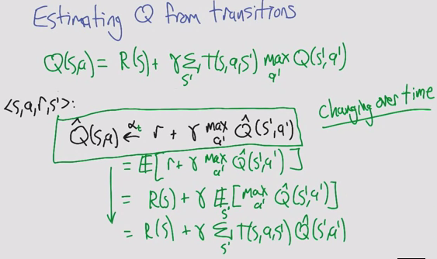

* Math tricks of expectations
* Simple update rule doesn’t actually work because Q^ is a changing target

Q learning convergence

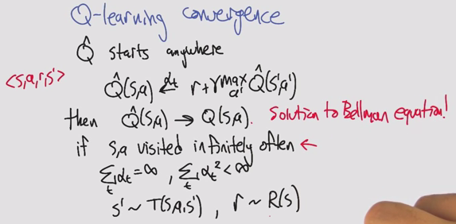

Choosing actions

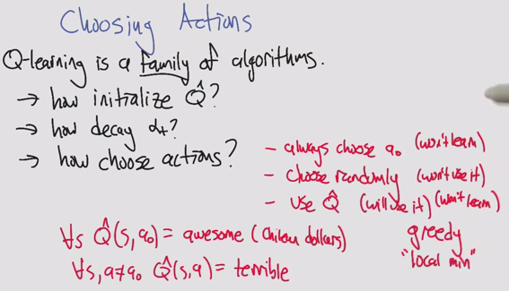

* Choosing bad actions
  + Always choose a0, ignoring q^
  + Choose randomly, wise but stupid. We know a lot, don’t do anything about it
* Greedy local min
  + Use random restarts!

Choosing actions (two)

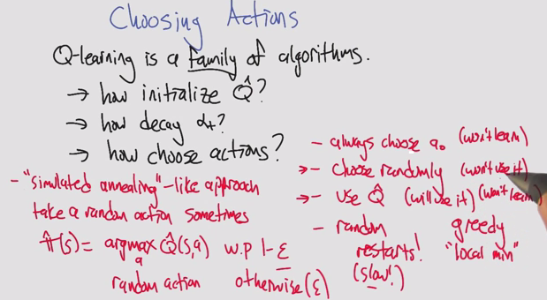

* Random optimization!
  + Simulated anneal: Random action sometimes

Greedy Exploration

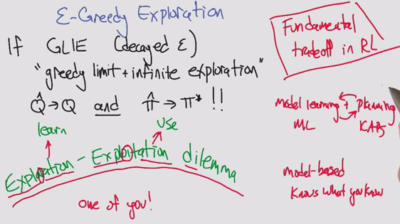

* Trade-off: Exploration & Exploitation

Summary

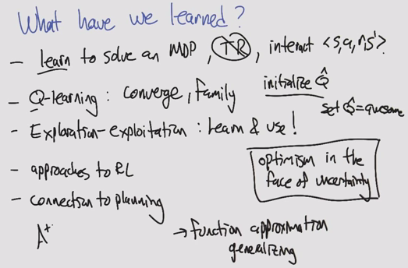

* Optimism in the face of uncertainty
* Issues of overfitting, importance of generalizing

### Lesson 3: Game Theory

Game Theory

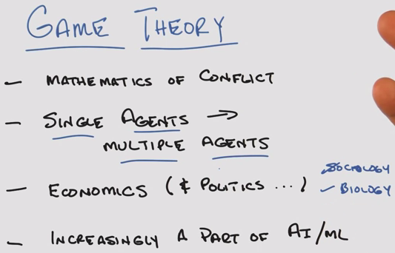

* Math of conflicts of interest
* Each agent has its own goals, intentions, interests

Quiz

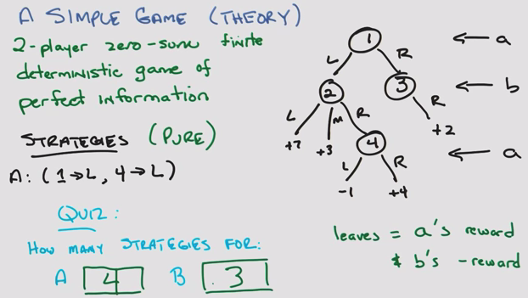

Another simple quiz

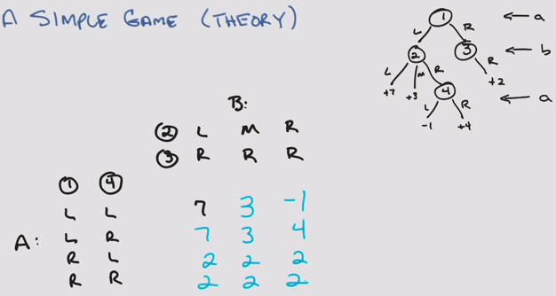

* Strategy and reward, the how is not important
* The only thing that matters is the matrix

Minimax: Value of the game

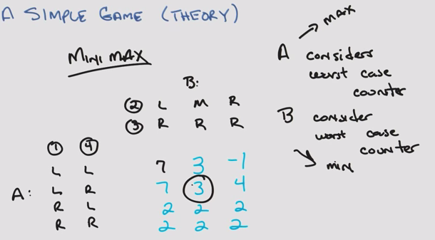

* A and B arrive at the same strategy

Fundamental result

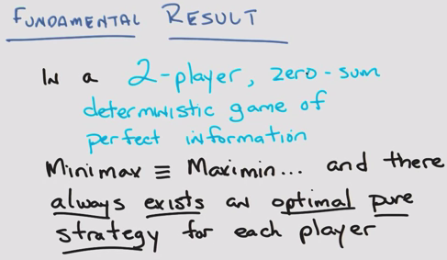

* Assume everyone is rational (trying for optimal, and assumes all other agents are maximizing)

Game tree

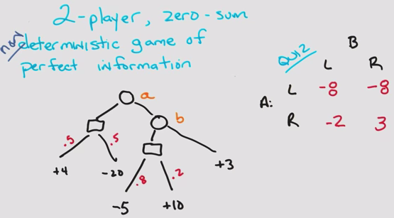

* Use the Expectation of stochastic probabilities
* Other theorem still holds! Von Neumann

Minipoker

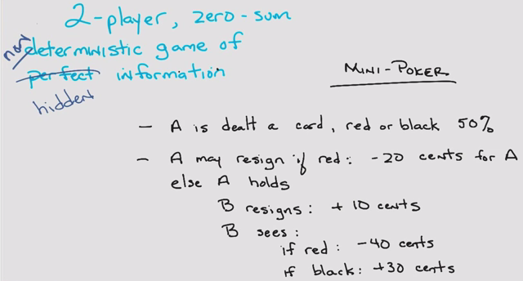

* Non-deterministic & hidden

Minipoker Tree

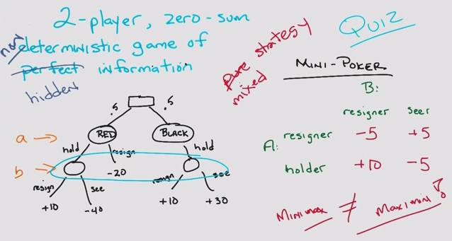

* Minimax != maximin

Quiz

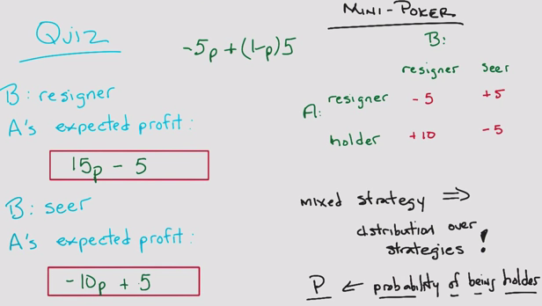

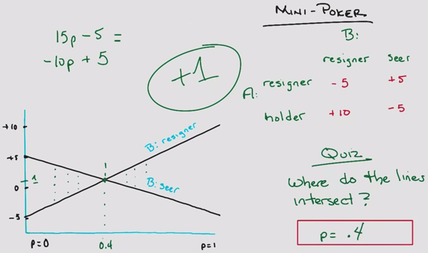

Center game

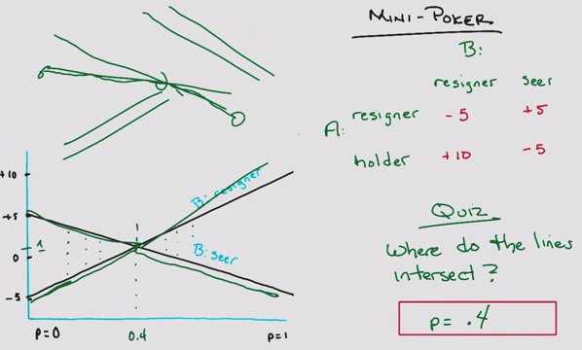

* Maximum of 3 discrete points: 2 extrema and intersection

Prisoner’s Dilemma

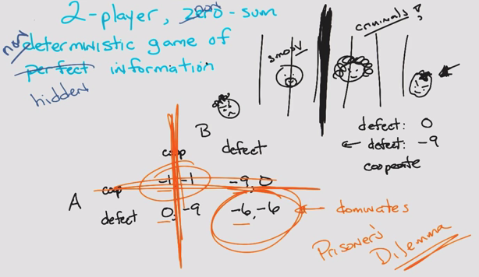

* Non-zero sum

A beautiful equilibrium

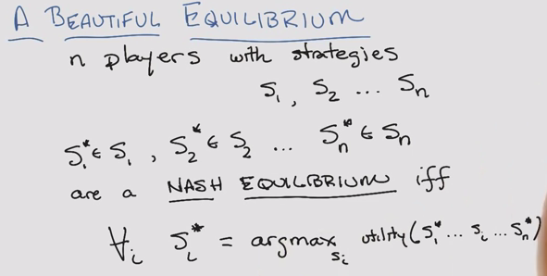

* John Nash: A Beautiful Mind

A Beautiful Equilibrium – Quiz

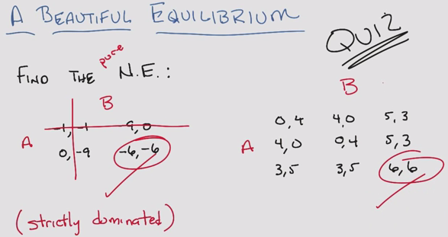

A Beautiful Equilibrium Two

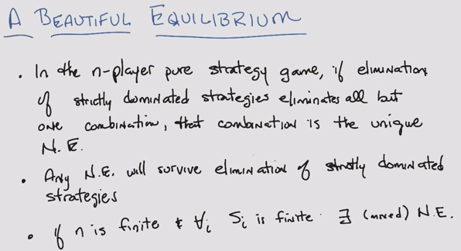

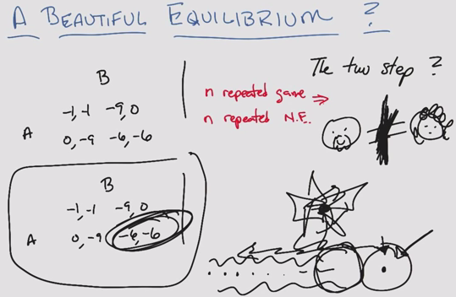

Summary

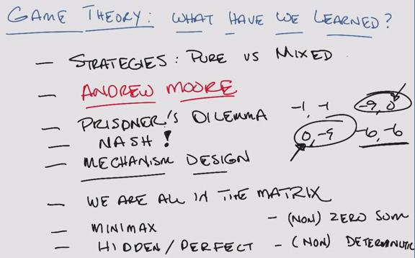

* Relaxed the constraints

### Lesson 4: Game Theory – Continued

Iterated Prisoner’s Dilemma

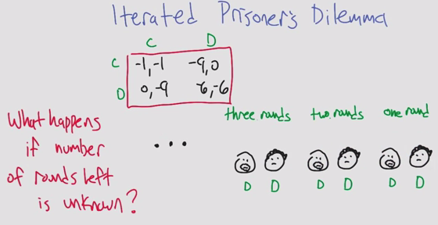

Uncertain End

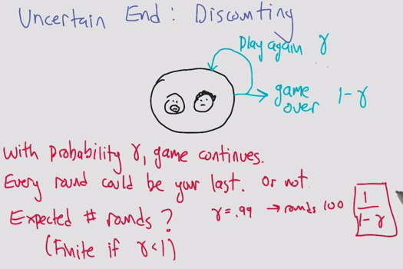

Tit for Tat

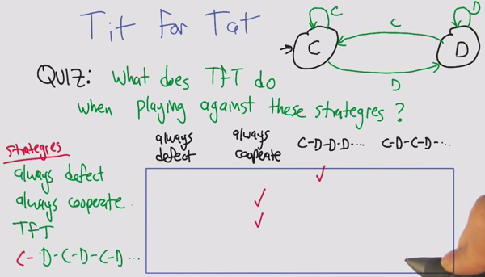

Facing Tit for Tat

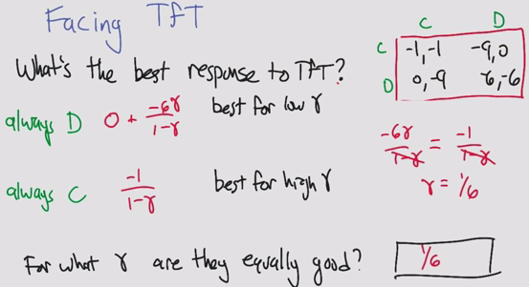

Finite State Strategy

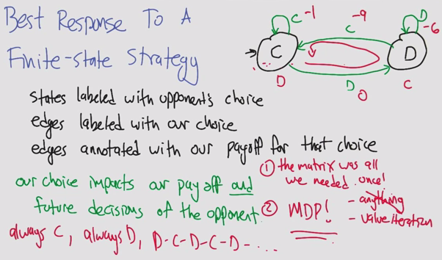

Best Responses in IPD

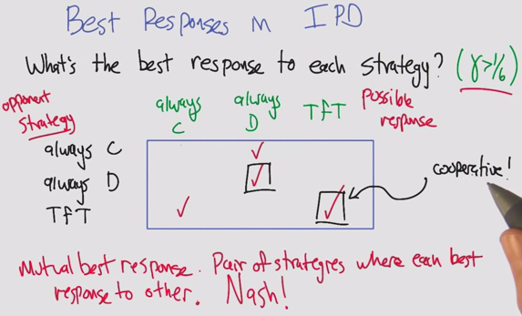

Folk Theorem

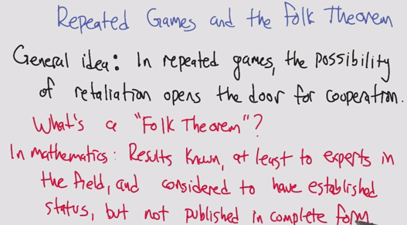

* NOT in game theory: General understanding, not credited to a specific person

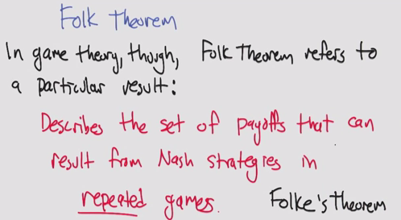

* In game theory: particular result

Repeated Games and the Folk Theorem

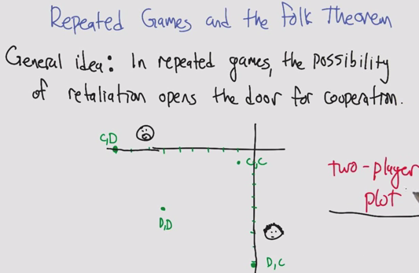

Repeated Games Quiz

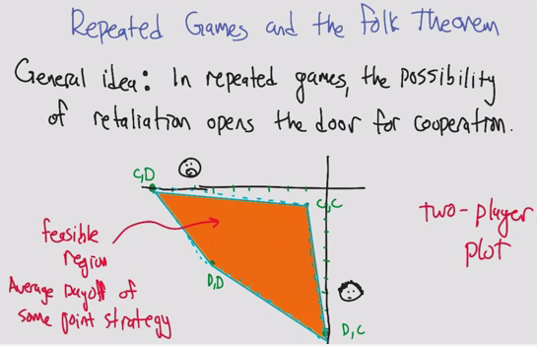

Minimax Profile

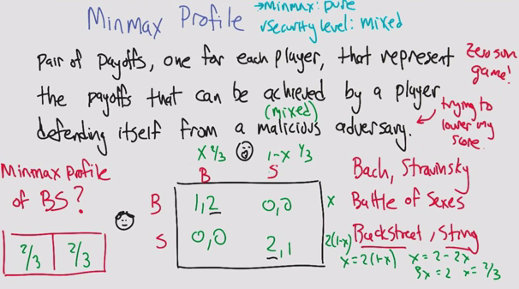

* Profile 1, 1 is minmax pure
* Mixed strategy allowed in security level

Security level Profile

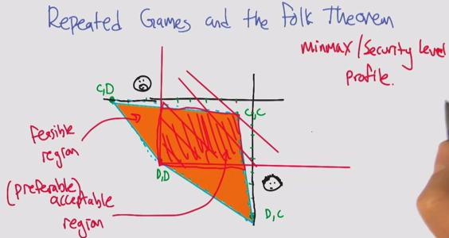

Folk Theorem

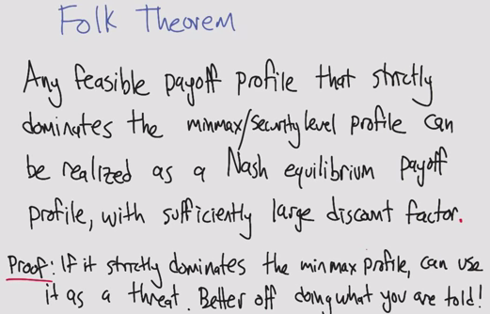

Grim Trigger

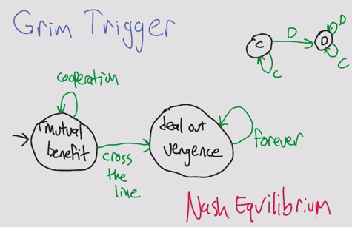

* Added to rational agents, each agent will become vengeful when the other defects
* Can’t do anything better against Grim than to use Grim, therefore Nash!

Implausible Threats

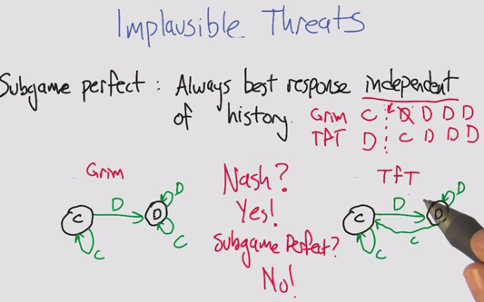

* Assuming that vengeful agents will forgo reward entirely
* Subgame perfect:

TfT vs. TfT

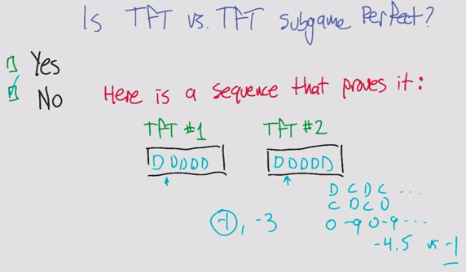

* If you were to change one agent’s actions, could you improve the expected value?

Pavlov

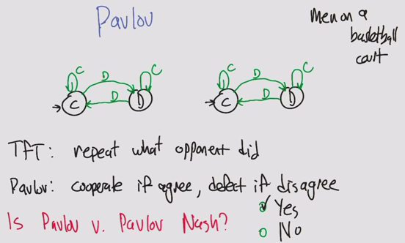

* Pavlov is Nash

Pavlov

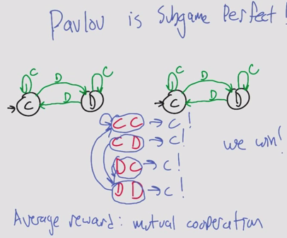

* Pavlov is Subgame Perfect
* Why is this interesting?
  + It becomes a plausible threat

Computational Folk Theorem

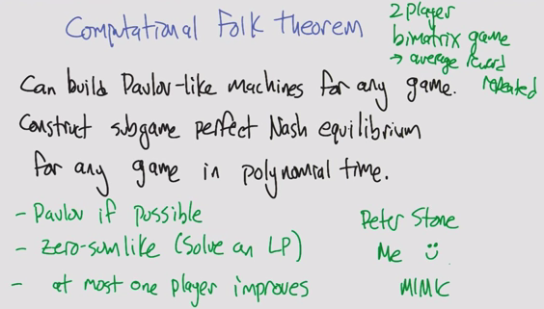

* Assume high discount factor
* Bimatrix if different reward structure per agent

Stochastic Games

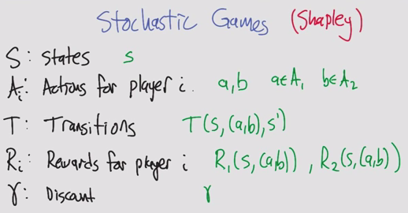

* Sometimes gamma is defined or inherent

Quiz

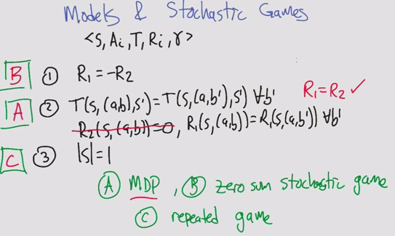

* B: Zero sum: easy
* A: Only one agent: MDP
* C: Only one state, same game. Actions affect rewards but not transitions

Zero sum stochastic games

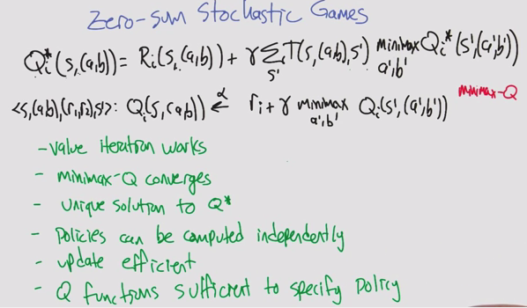

* Zero-sum game assumes 2 players. 3 players is general sum with one player to make the sum 0
* Use minimax Q (max Q for a’ b’ does not make sense, since it is zero sum)
* Minimax can be solved using a linear program
* It’s like a 1 agent game, but now with 2

General sum stochastic games

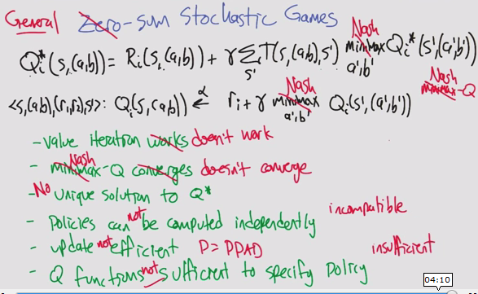

* Minimax doesn’t work with 3+ players
  + Replace with Nash
  + PPAD, as hard as NP for computation time
* Many many difficulties

Lots of ideas

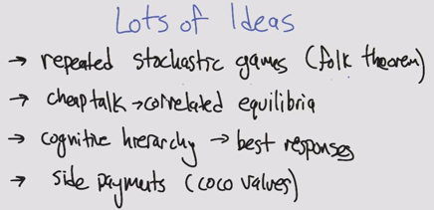

* Coco: cooperative competitive values

Summary

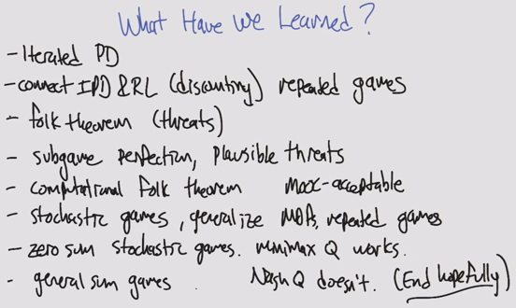

# Extracurricular Learning

* O notation
  + <http://cglab.ca/~morin/teaching/2402/notes/bigoh.pdf>
  + O(g(n)) is a set of functions that contains f(n)
* Eigenproblems
* Math of policies, converging
* Andrew Moore

# ML Terminology

* Monotonic: One direction
* Non-Increasing: Equal or smaller
* Clustering: Richness, Scale-Invariance, Consistency
* Mutually Contradictory
* Strongly/weakly relevant & irrelevant have to do with ***information***
* Usefulness has to do with ***error***
* Polysemy: word has multiple meanings. False positives
* Synonymy: same meaning expressed in different words. False negatives

# Practice Questions

1. Explain the difference between filtering and wrapping in feature selection.